Name= Mina Bohora

Section= A

Roll no=5797

1. Adding files to the new folder.

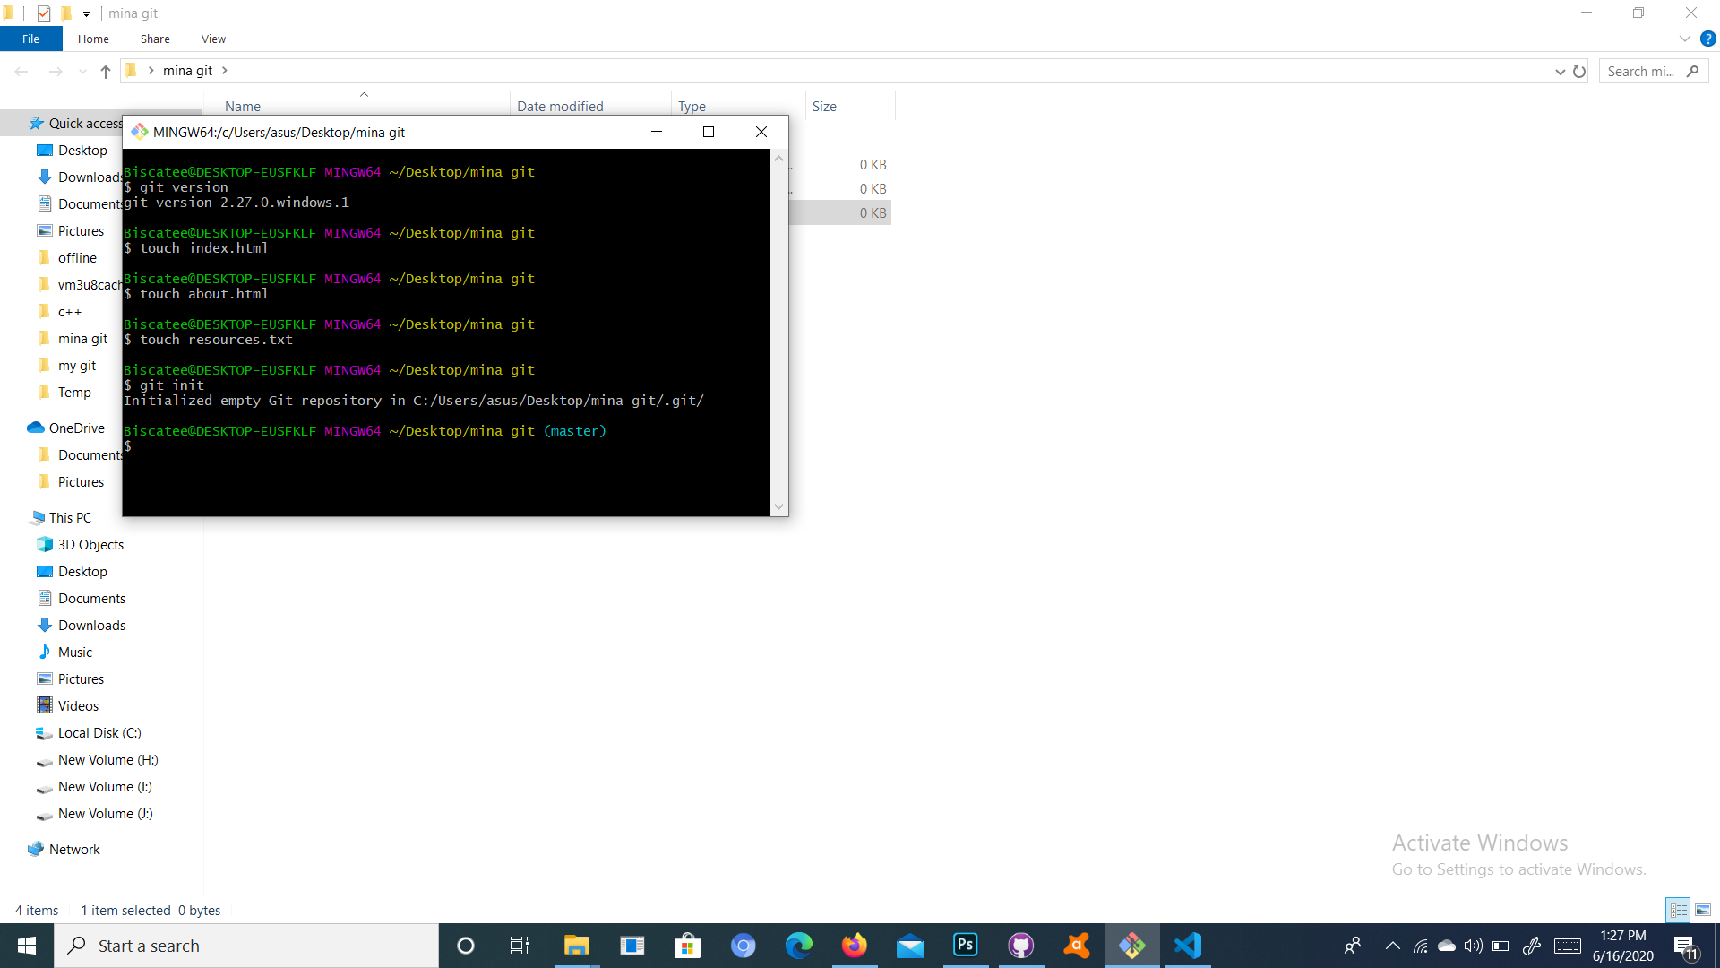

2. Writing on resources. txt, index.html , touch about html and initializing the Git repository / working directory and configuring user name and email and checking the status and adding files.

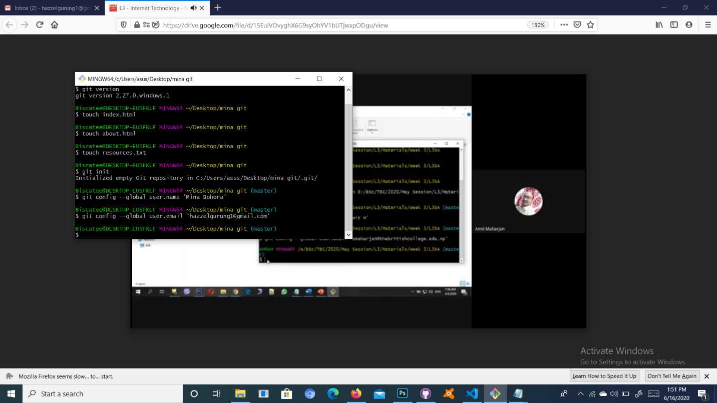

3. Committing the changes in working directory.

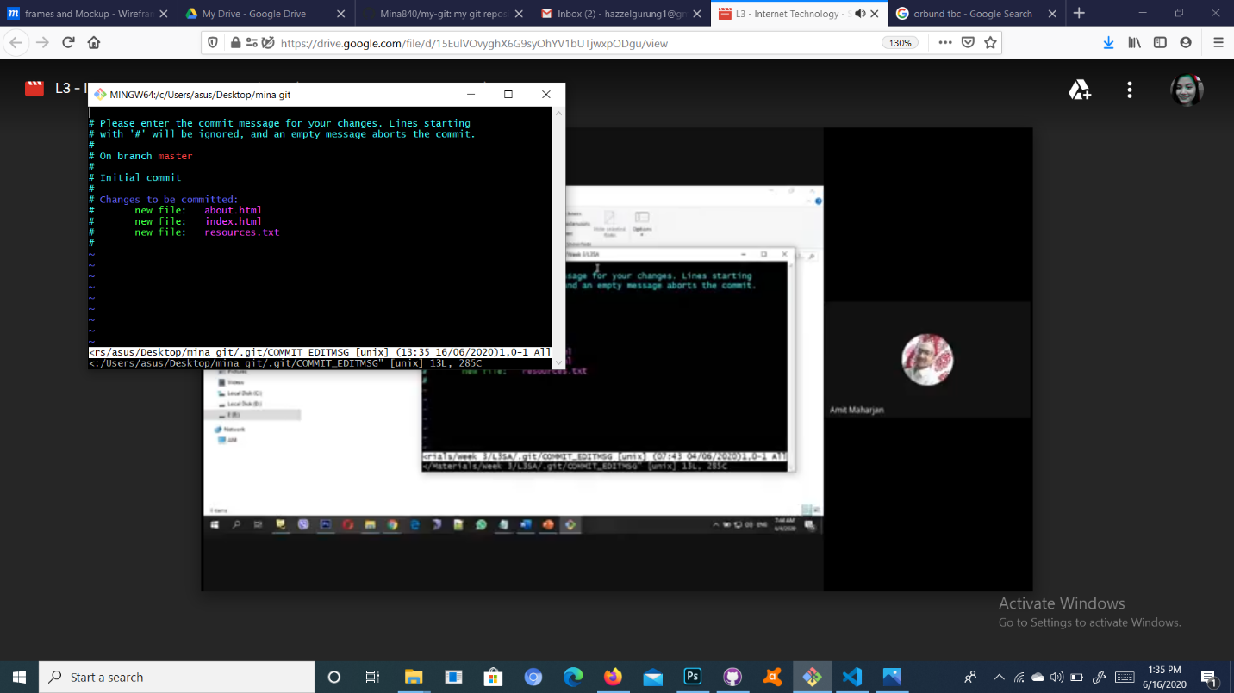

4. Checking the status and applying changes/adding texts in the document and checking the status. (Optional) and adding the file and committing the change and viewing the commit history.

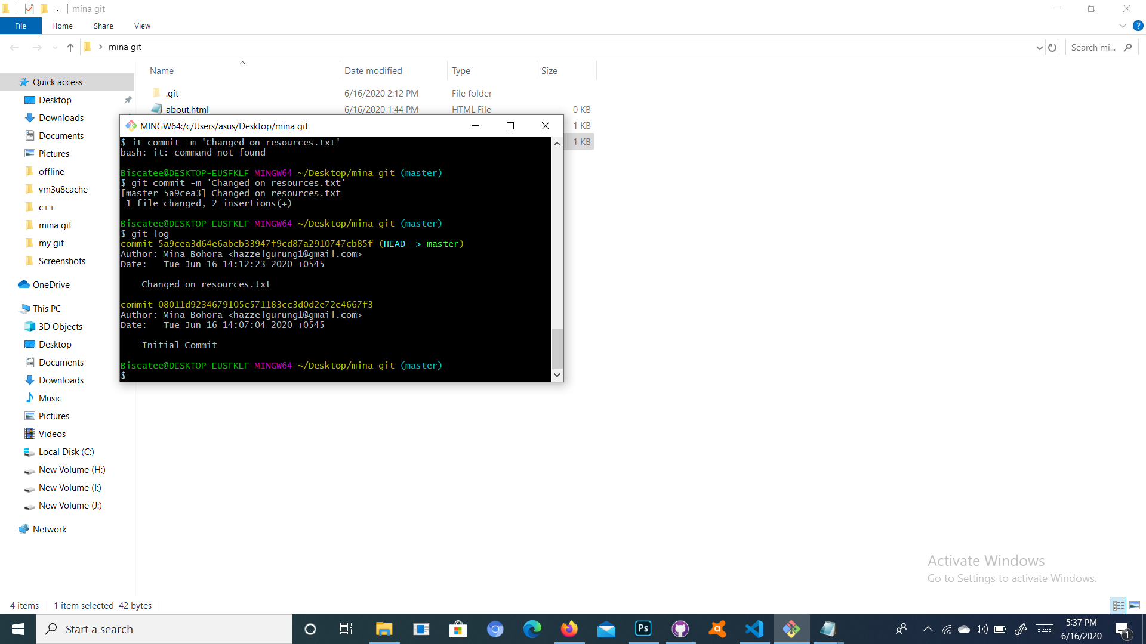

Task 2;

5. New repository named Mina git created and adding the origin and pushing the files.

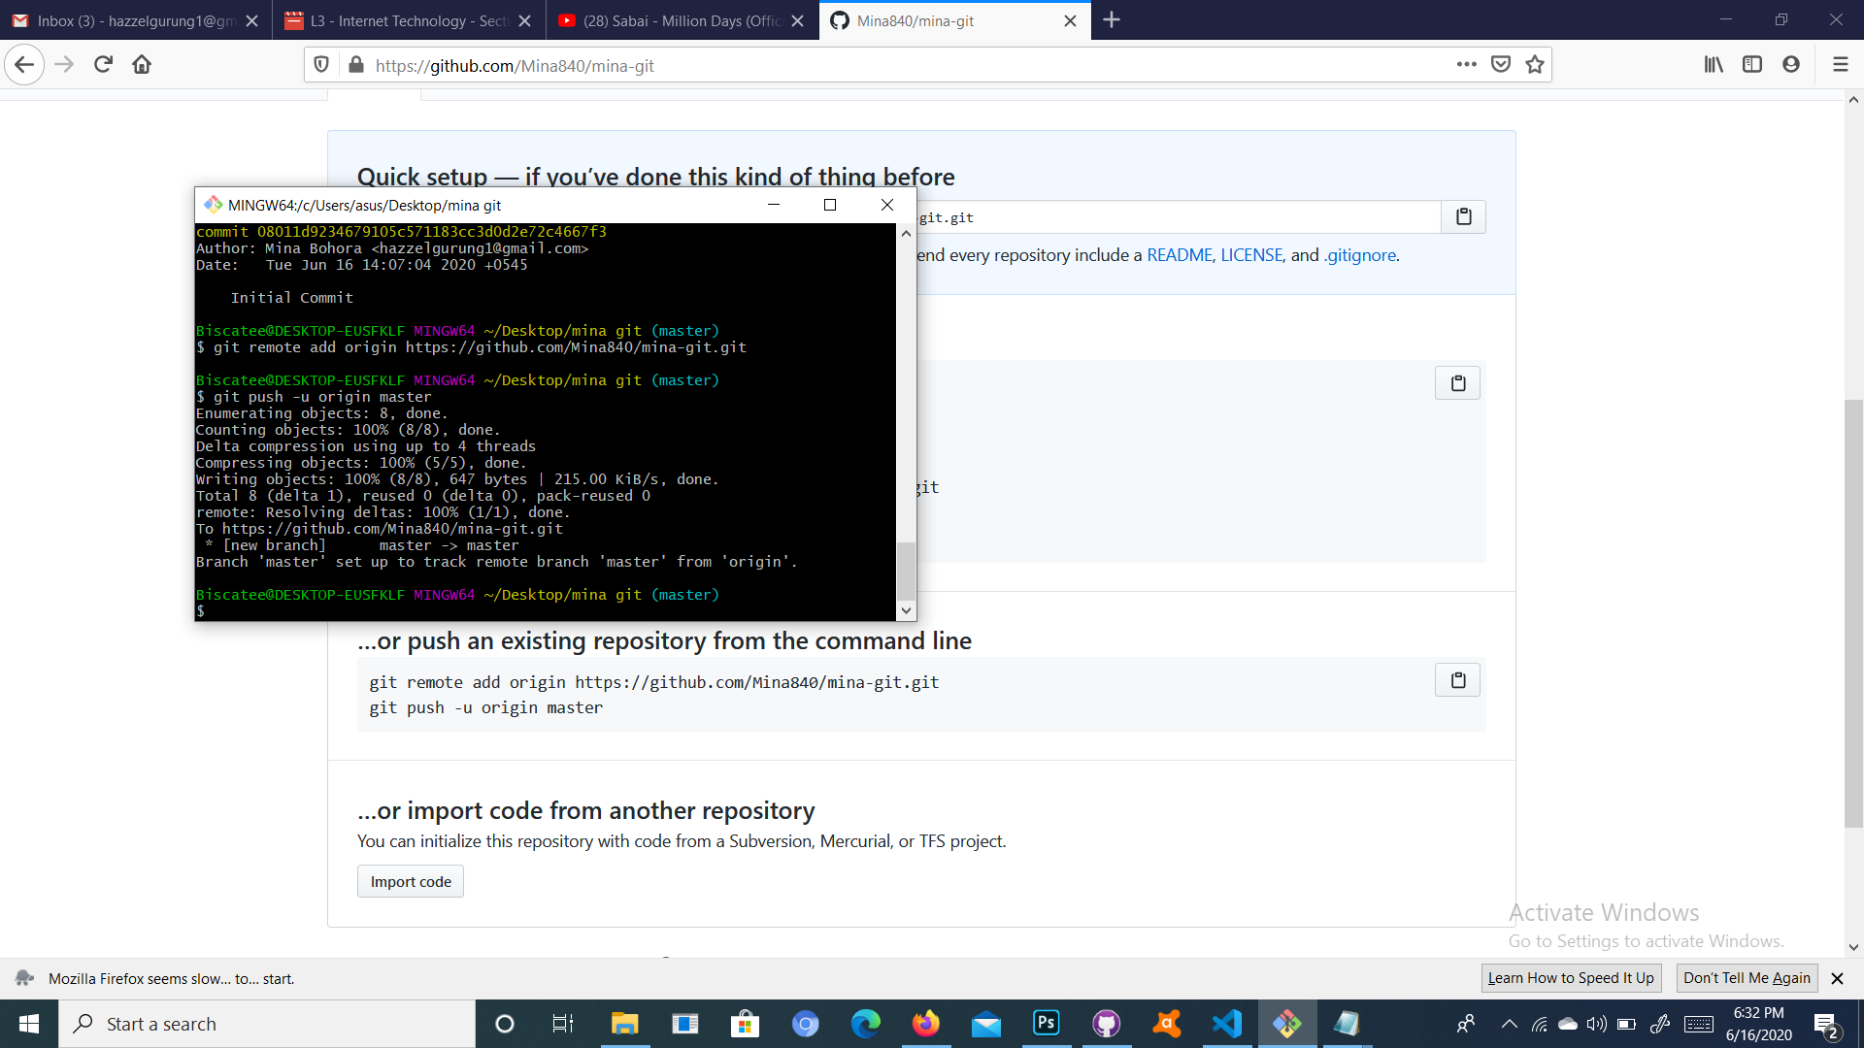

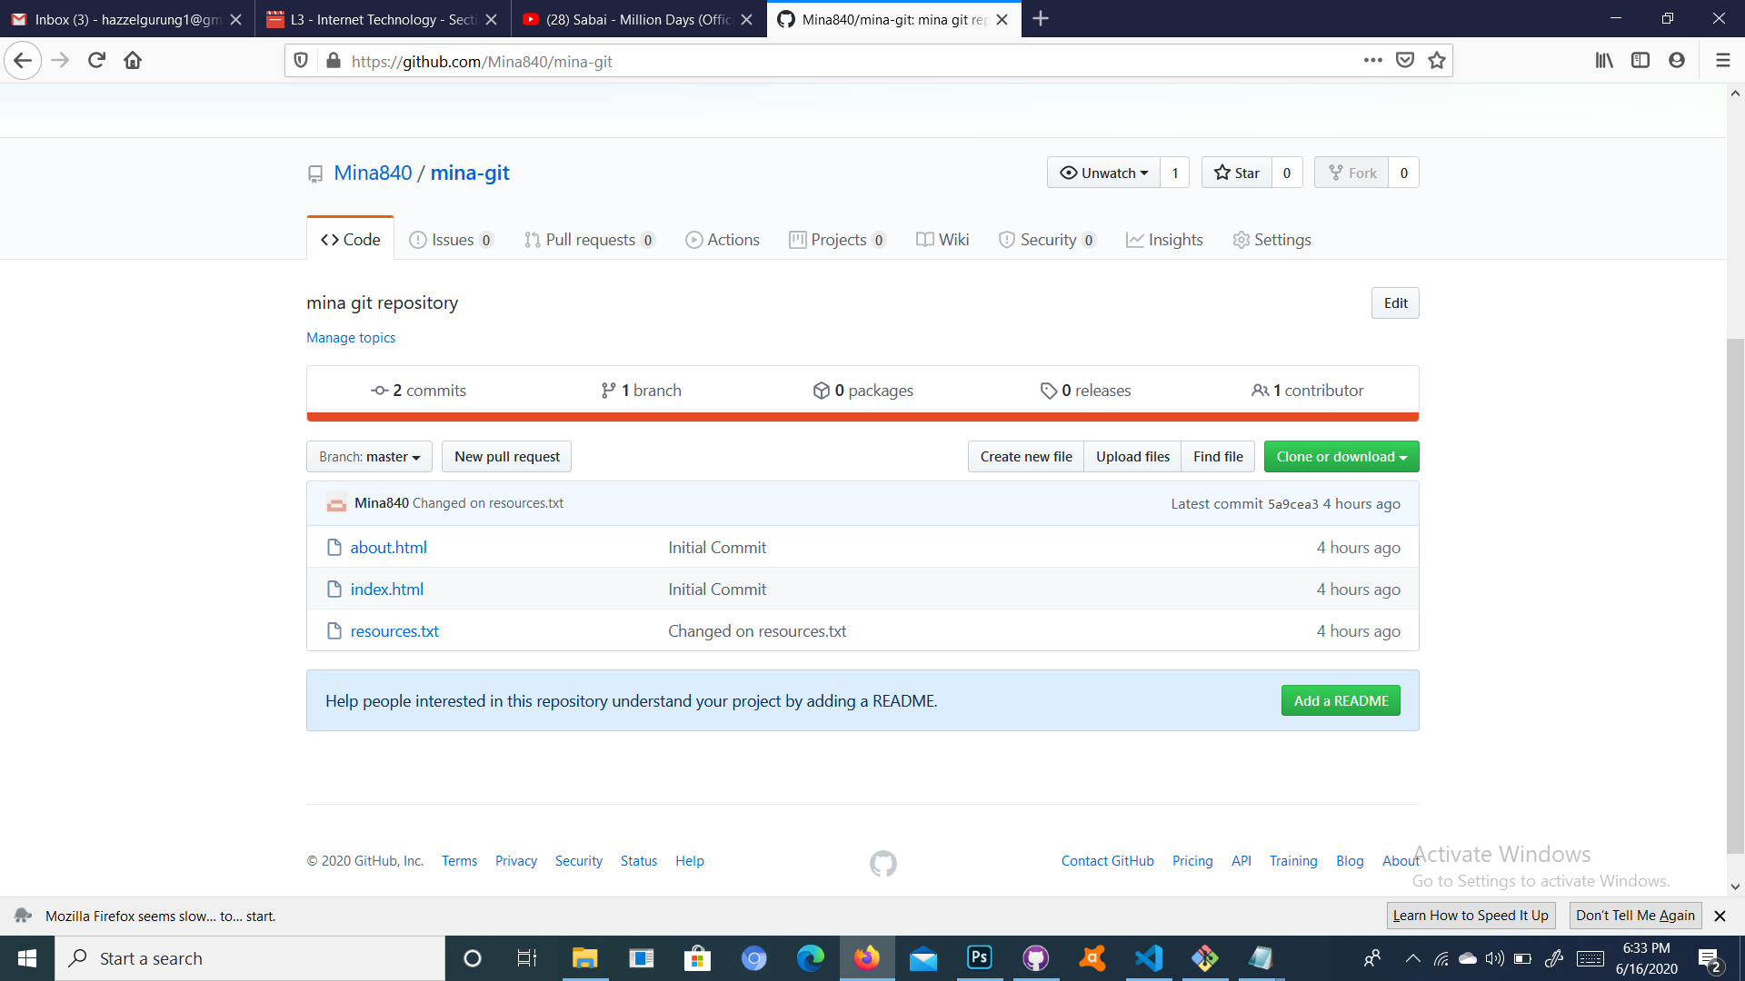

6. Cloning the github repository. 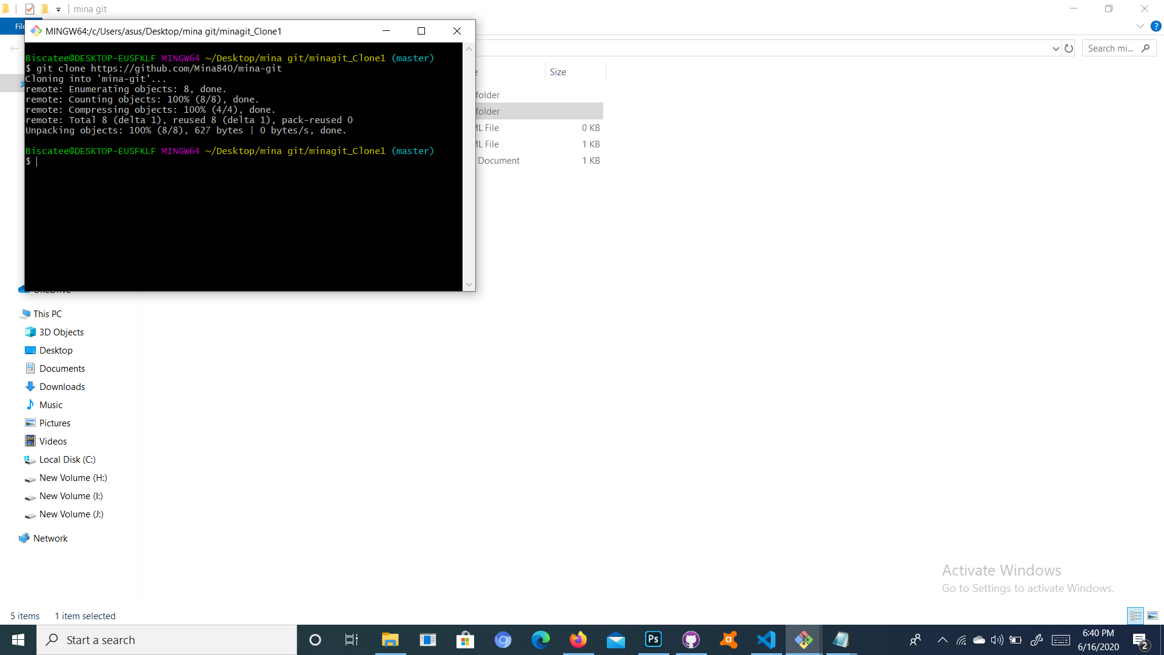

Task 3;

7. Creating a new branch “Branch-1” and switching to the new branch and adding files on the new branch and committing the changes and pushing the new branch on github.

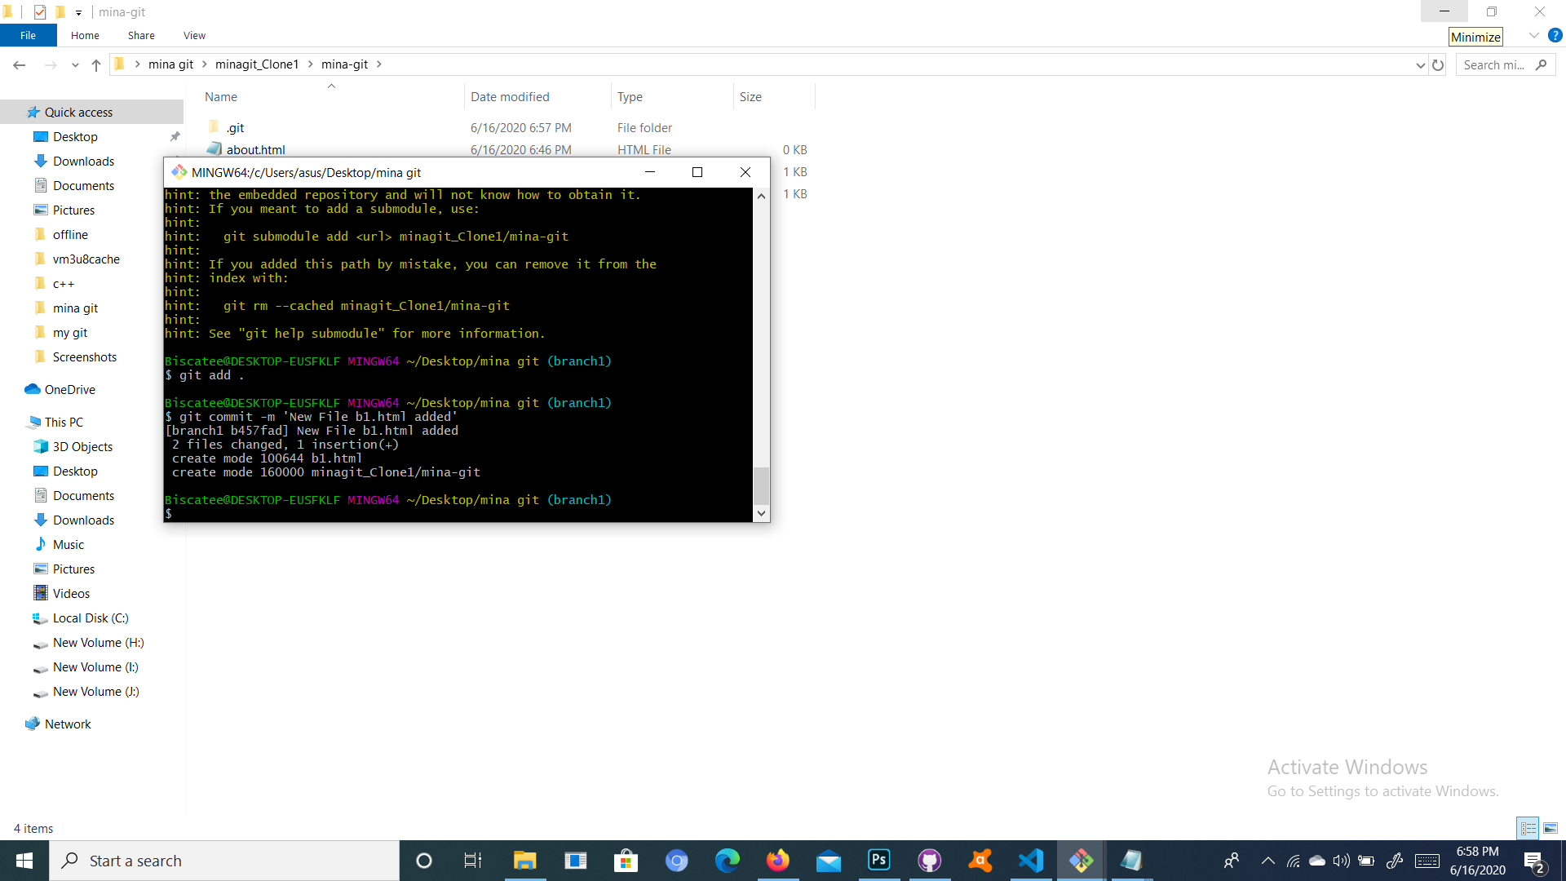

We can view b1 in master branch.

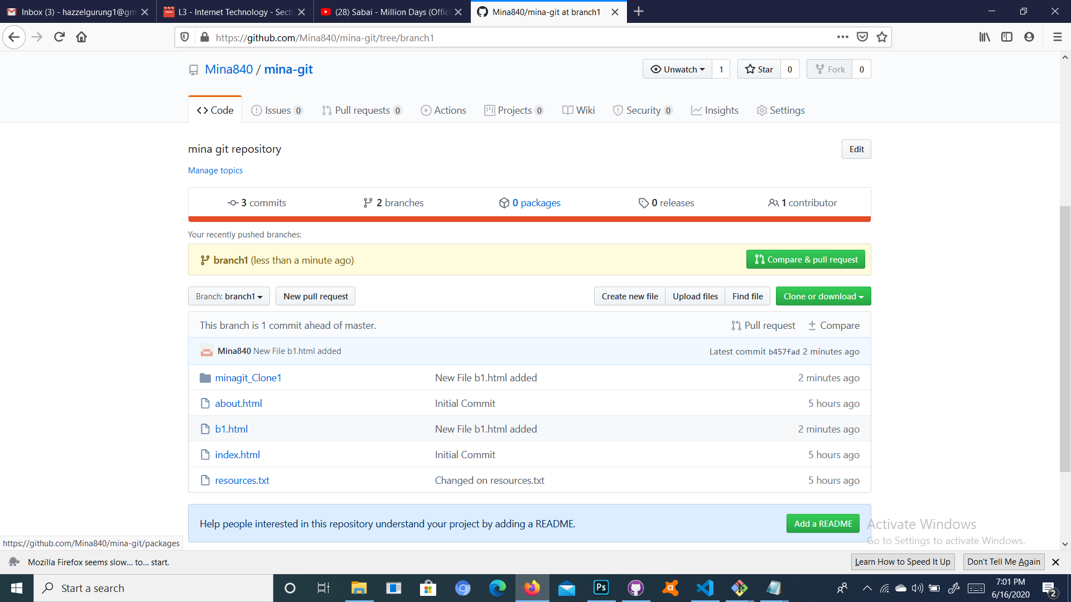

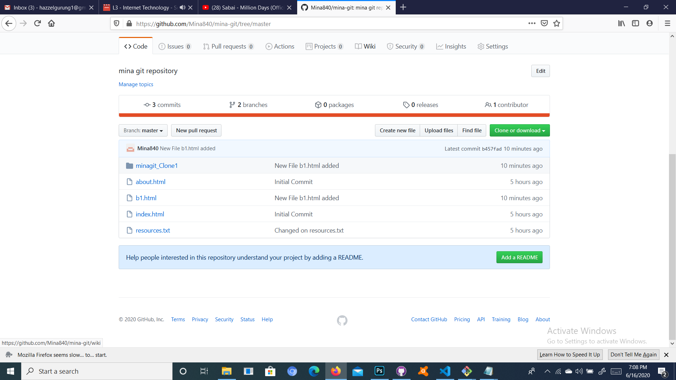

Task 4;

8. Successfully downloaded and logged in to github desktop.

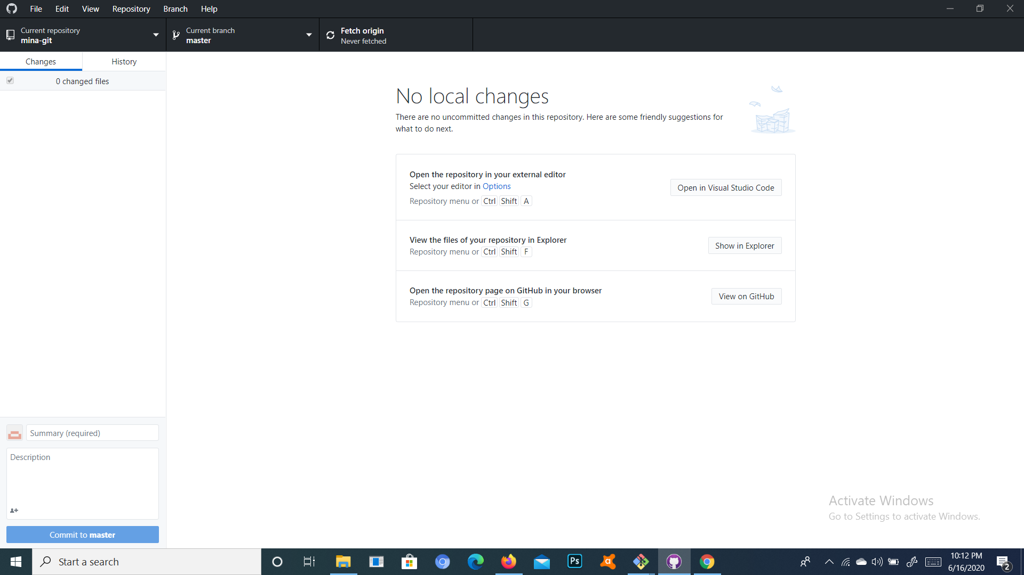

9. Creating a new file in local repository, committing and pushing it to GitHub using GitHub Desktop.

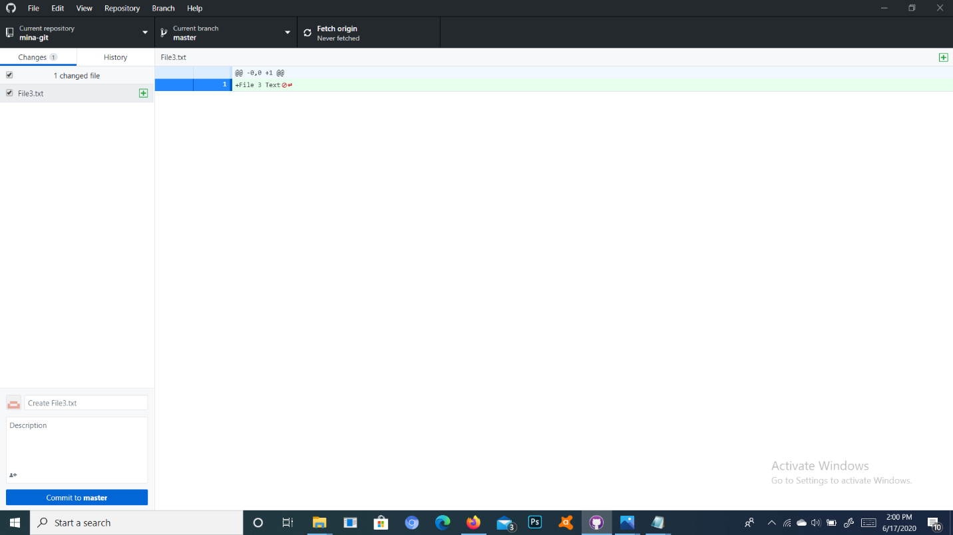

We can see the new file ( File3.txt) in our github repository.

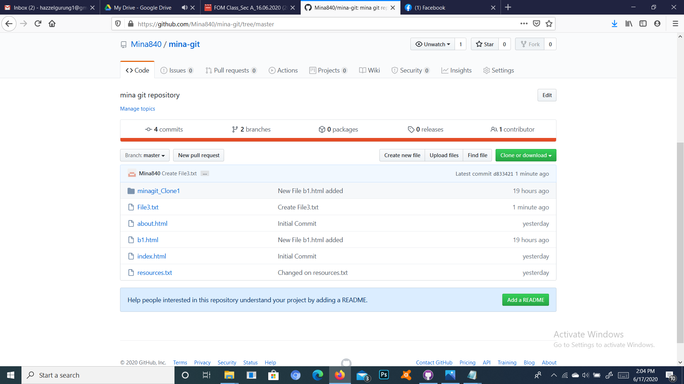

10. Publishing and pulling the current branch in github desktop.

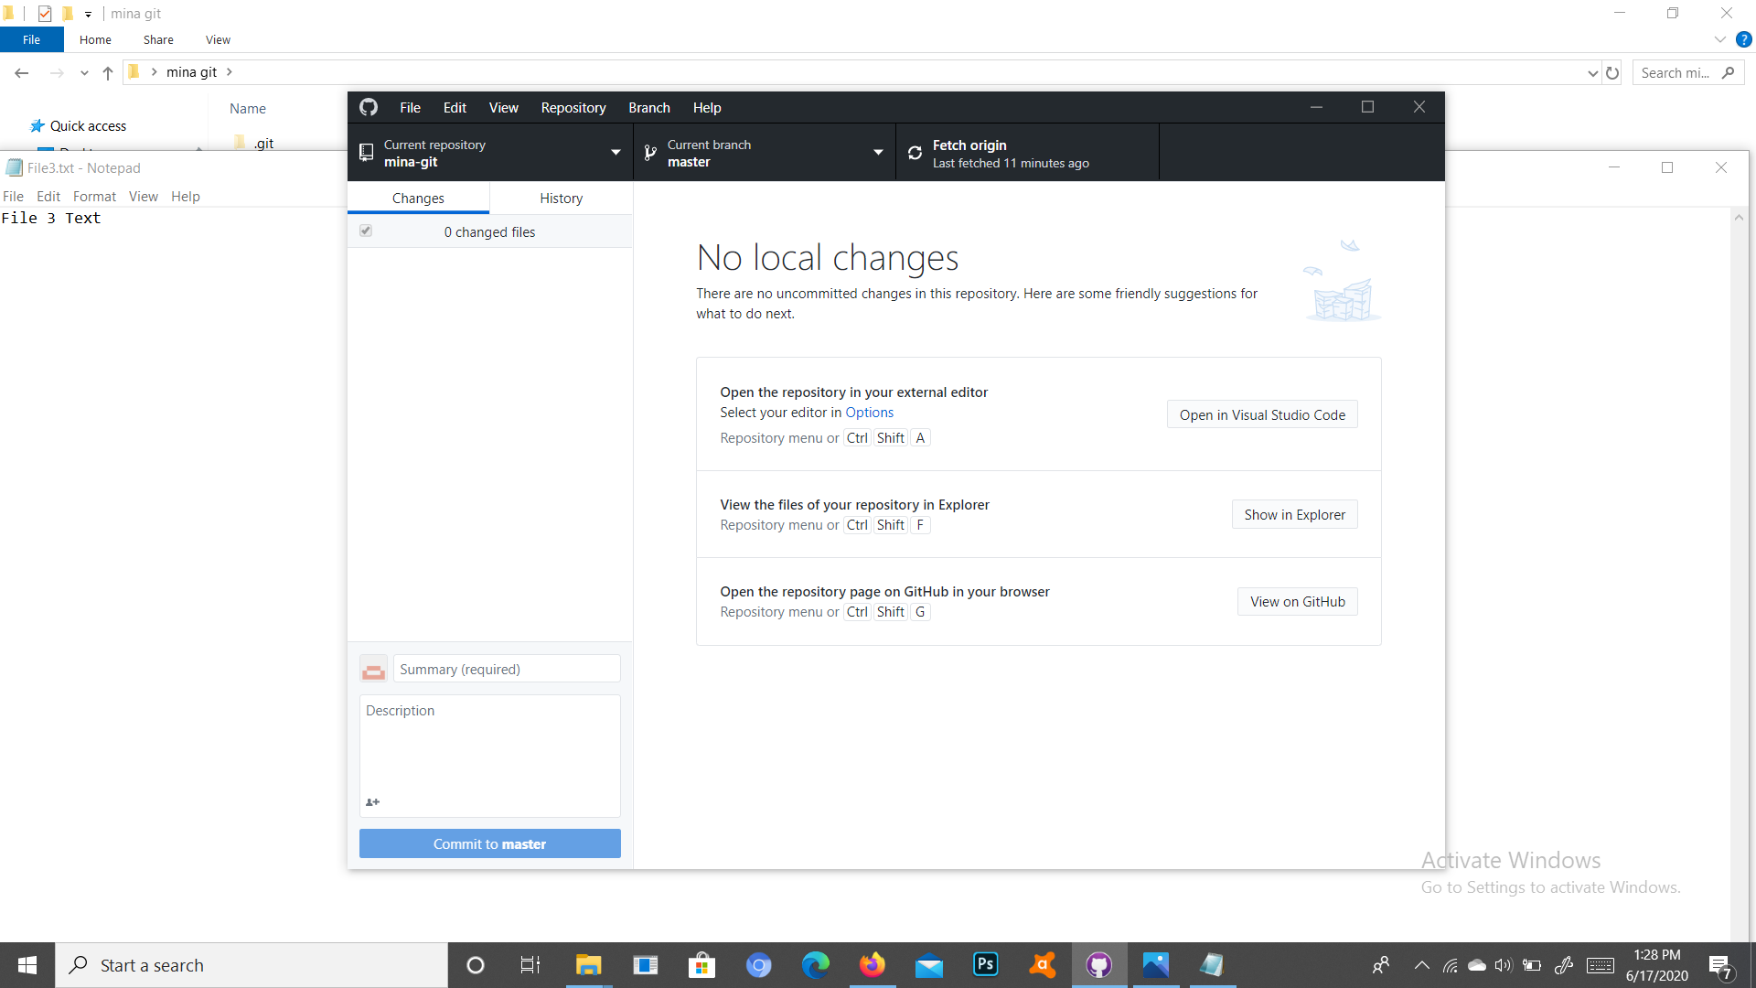

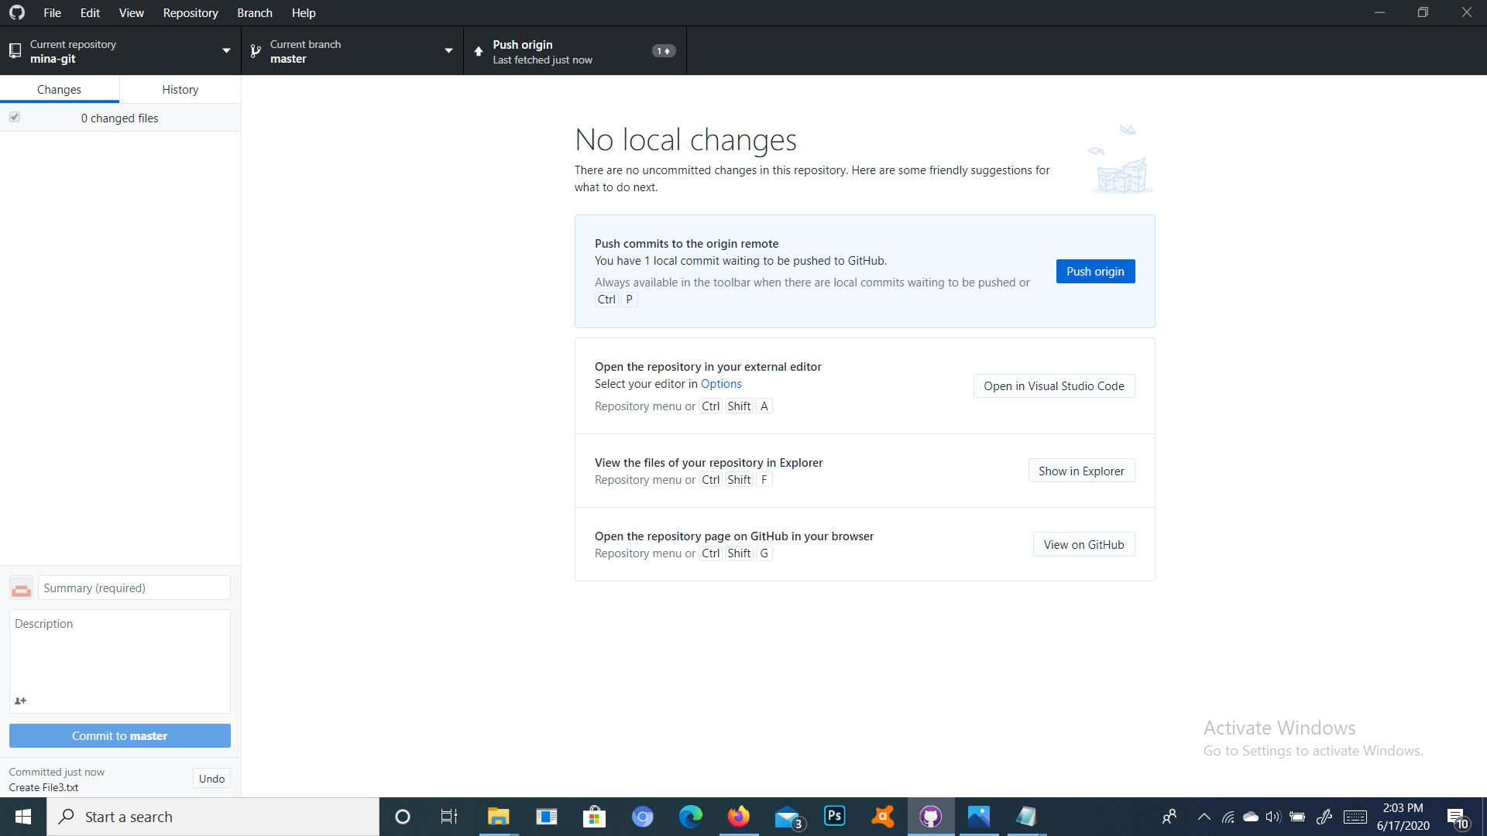

11. This is the final result.

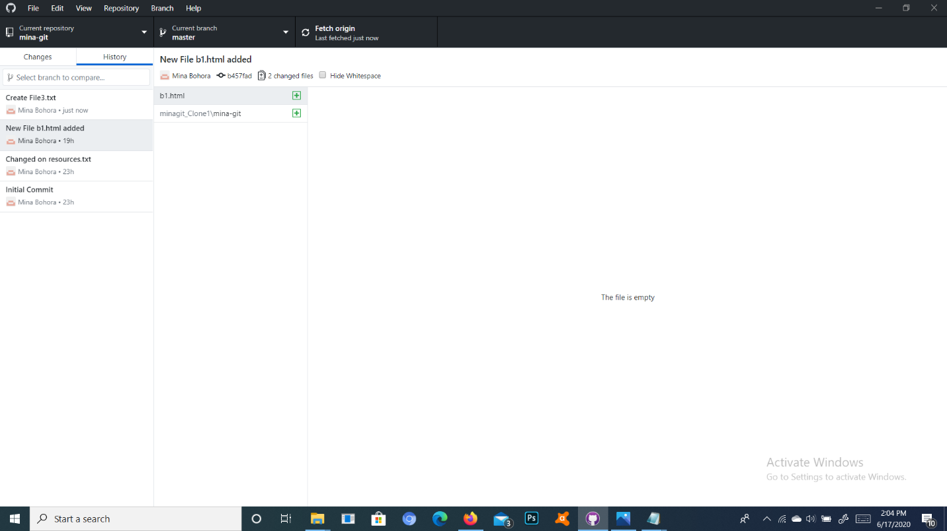

Link to the github = <https://github.com/Mina840/mina-git/tree/master>